# Documentation Cloud Magic App

## Programming :: Mean Stack

### Angular Js - Modules :: Moment Js

### Bootstrap

### CSS3

### HTML 5

### Node JS – Modules :: Express, bluebird, body-Parser, Path, underscore, moment

## How to start ---

* *Go to the downloaded folder and open cmd window.*
* *Give npm install to install all dependencies.*
* *Go again to cmd and write node controller.js then open, localhost:8083*

## BACK-END :-

### Api’s

#### API 1 - To Fetch All Messages ::

|  |  |
| --- | --- |
| URL :: | http://localhost:8083/allMessages |
| Method :: | GET |
| Response :: | [  {  "subject": "With regard to our conversation earlier today",  "participants": [  "Socrates",  "Confucius"  ],  "preview": "With regard to our conversation earlier today",  "isRead": false,  "isStarred": false,  "ts": 1464561786,  "id": 1  },  {  "subject": "Critique of Judgement - 30 copies",  "participants": [  "David Hume"  ],  "preview": "Hello, can you please send a quote for Critique of Judgement - 30 copies.....",  "isRead": false,  "isStarred": true,  "ts": 1464561726,  "id": 2  },  {  "subject": "Artwork for \"Collection of Plato's Dialogues\"",  "participants": [  "Plato"  ],  "preview": "Aristotle,\nI shortlisted a designed from Dribble",  "isRead": true,  "isStarred": false,  "ts": 1464561666,  "id": 3  }  ] |

#### API 1 - To Fetch a specific Message ::

|  |  |
| --- | --- |
| URL :: | http://localhost:8083/message/:messageId |
| Method :: | GET |
| Response :: | {  "subject": "With regard to our conversation earlier today",  "participants": [  {  "name": "Socrates",  "email": "socrates@gmail.com"  },  {  "name": "Confucius",  "email": "confucius@gmail.com"  }  ],  "preview": "With regard to our conversation earlier today",  "isRead": false,  "isStarred": false,  "id": 1,  "body": "Lorem ipsum dolor sit amet, consectetur adipiscing elit. Maecenas egestas leo sit amet justo vehicula tincidunt. Nullam a ipsum vitae ipsum feugiat sodales gravida quis nibh. Integer sed condimentum mauris. Maecenas venenatis purus quis nisl consequat, ac iaculis mi congue. Nunc ac turpis vel sapien maximus iaculis. Nunc in mollis lectus. Cras sem nisi, auctor eu malesuada consectetur, bibendum et tortor. Ut interdum nisl sed magna ullamcorper, ut pulvinar ligula luctus. Class aptent taciti sociosqu ad litora torquent per conubia nostra, per inceptos himenaeos.Etiam in tempor est. Praesent egestas rutrum ex sed ornare. Duis mi neque, vehicula et vehicula ut, convallis nec felis. Morbi mattis vitae massa sed rhoncus. Integer pulvinar tincidunt eros. Etiam ornare metus ac viverra placerat. Integer vel nunc et quam varius accumsan at in nibh. Fusce at luctus odio, vitae dictum mauris. Nulla facilisi. Cras non lorem porta, porta neque quis, ornare urna. Proin eleifend pretium neque id vestibulum. Ut condimentum mauris nec ipsum mollis molestie. Vivamus at erat lorem. In odio dui, molestie a accumsan sit amet, semper sed arcu. Sed ornare sed justo a ultrices. Fusce non consectetur lacus.",  "ts": 1464562353  } |

#### API 1 - To Delete a specific Message::

|  |  |
| --- | --- |
| URL :: | http://localhost:8083/message/:messageId |
| Method :: | DELETE |
| Response :: | Message Deleted |

## FRONT-END :-

var app = angular.module('myApp', ['angularMoment']);

//Designing the controller part

app.controller('myCtrl', function($scope,$http) {

//On Page load the following will happen

//Requesting to fetch all messges

$http({

method: 'GET',

url: 'http://localhost:8083/allMessages'

}).then(function successCallback(response) {

$scope.data = response.data;

$scope.imageValue = "star_border";

}, function errorCallback(response) {

});

//When we click delete

$scope.toDelete = function(toDeleteId){

$http({

method: 'DELETE',

url: 'http://localhost:8083/message/'+toDeleteId

}).then(function successCallback(response) {

reload();

}, function errorCallback(response) {

console.log("Error Unable to Delete Message with Id"+toDeleteId);

reload();

});

}

//Generic function to reload the page

var reload = function(){

console.log("coming to reload");

location.reload();

}

// opening the message

$scope.messageDisplay = function(messageId){

console.log("messageId :: "+ messageId);

$http({

method: 'GET',

url: 'http://localhost:8083/message/'+messageId

}).then(function successCallback(response) {

console.log("response :: "+ JSON.stringify(response.data));

$scope.messageContent = response.data;

}, function errorCallback(response) {

console.log("Error Unable to get Message with Id"+messageId);

});

}

//Using ng-Class to decide if the message has been read or not

$scope.whatClassIsIt = function(isRead){

if(isRead == true){

return 'messageWellRead'

}

if(isRead == false){

return 'messageWellUnread'

}

}

});

# Functionality :-

# So as I have made the ui using bootstrap (which is a mobile first technology); I have made it for both web and mobile app.

## When we open the index url :

## Web View ::

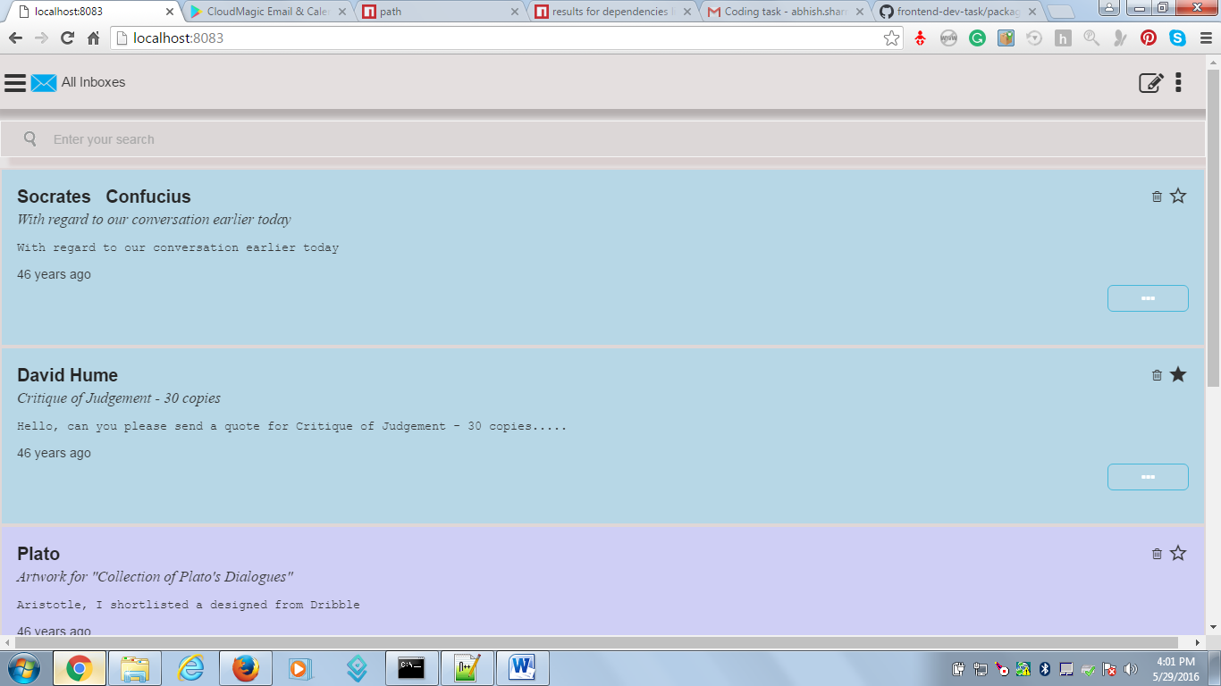

## Mobile view ::

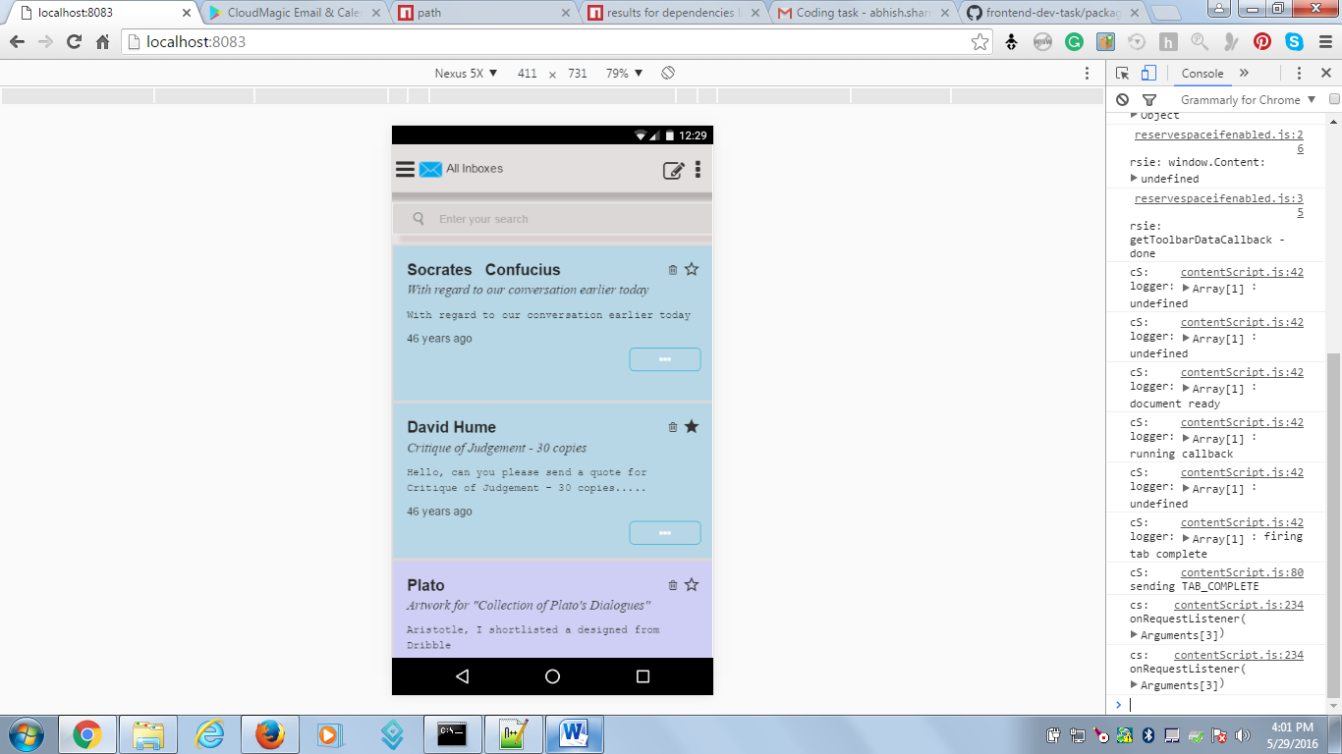

## Search down the mail you need from the list of Junk mails ::

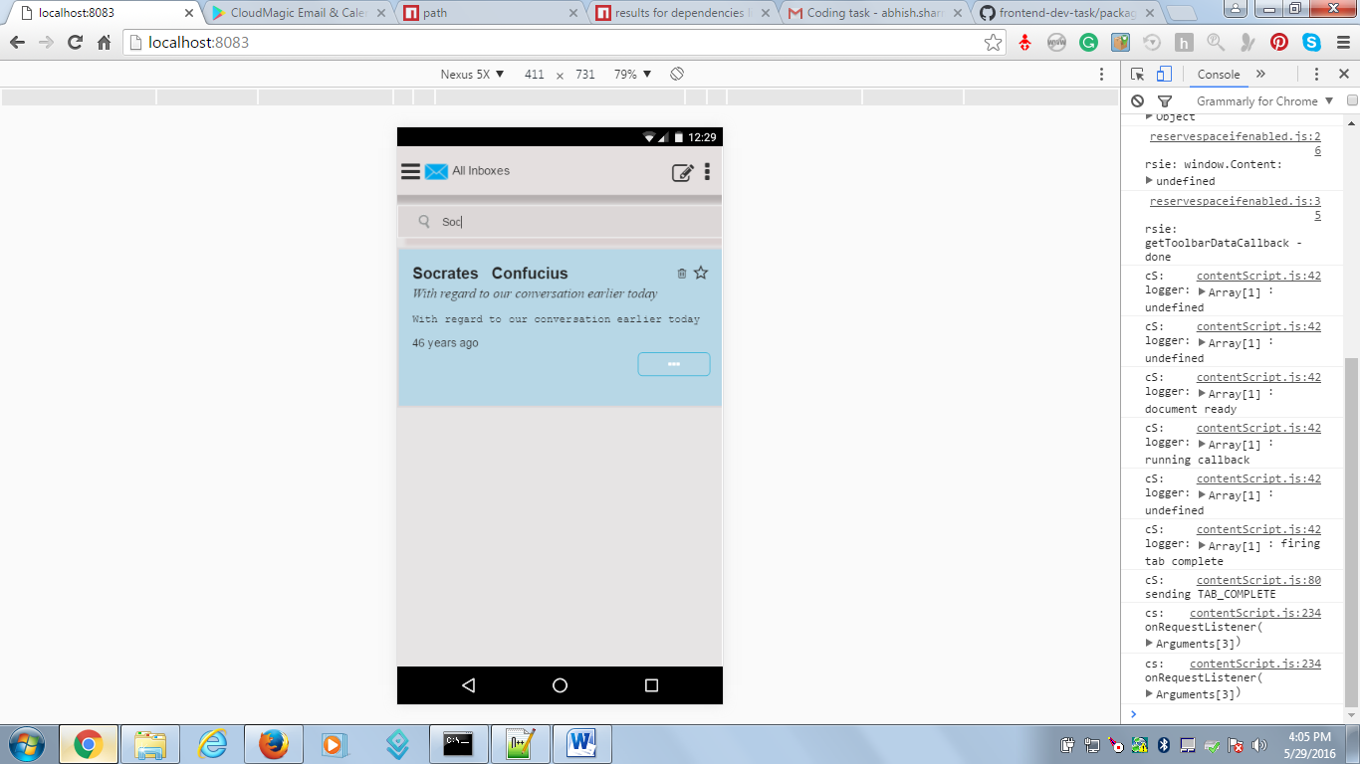

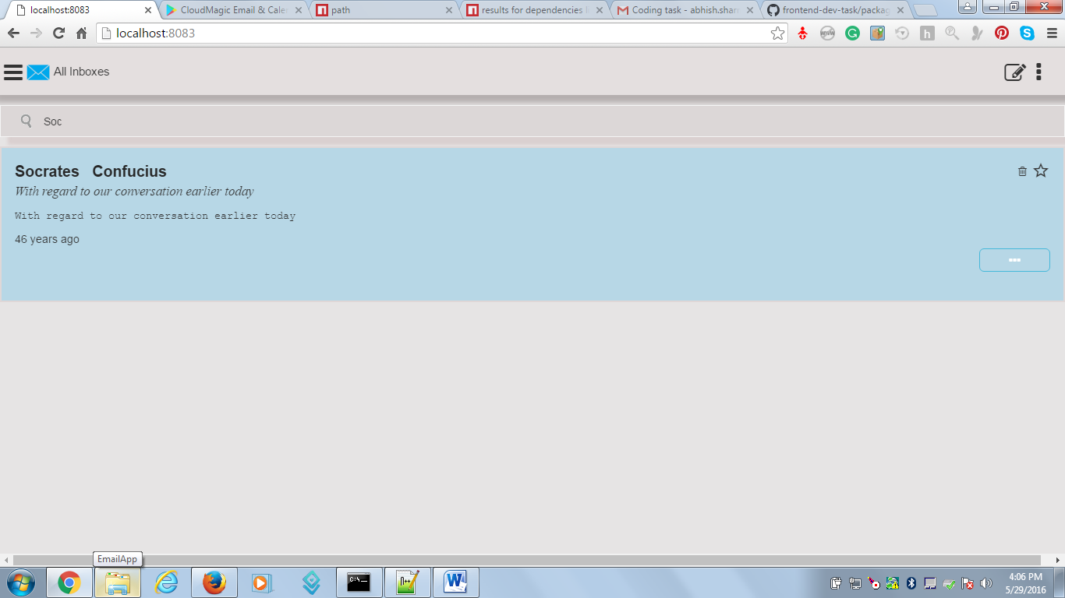

## Making a mail as your favourite Just by clicking on the star button :-

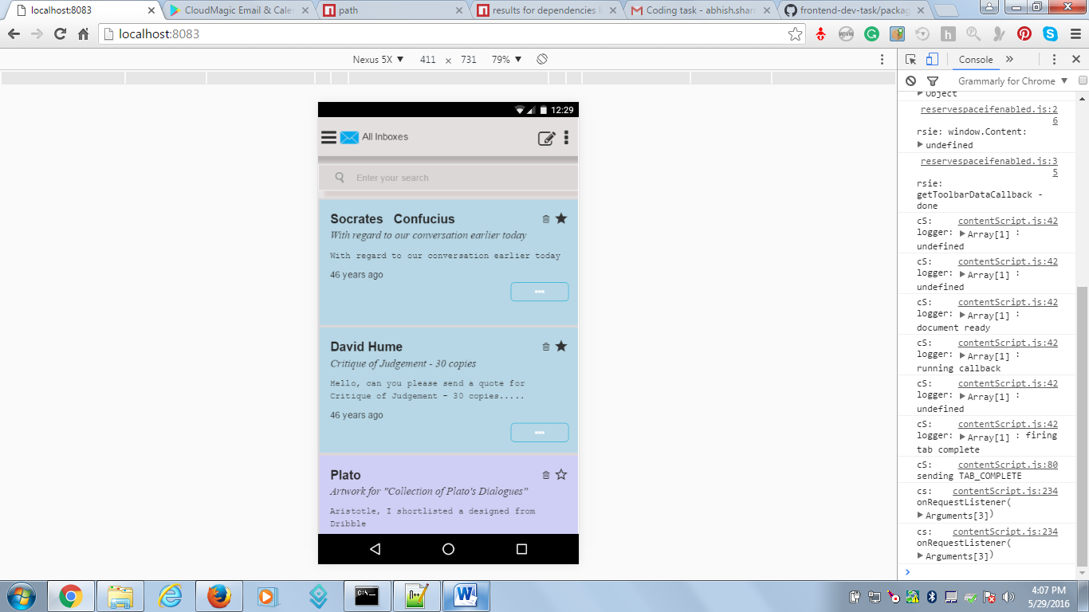

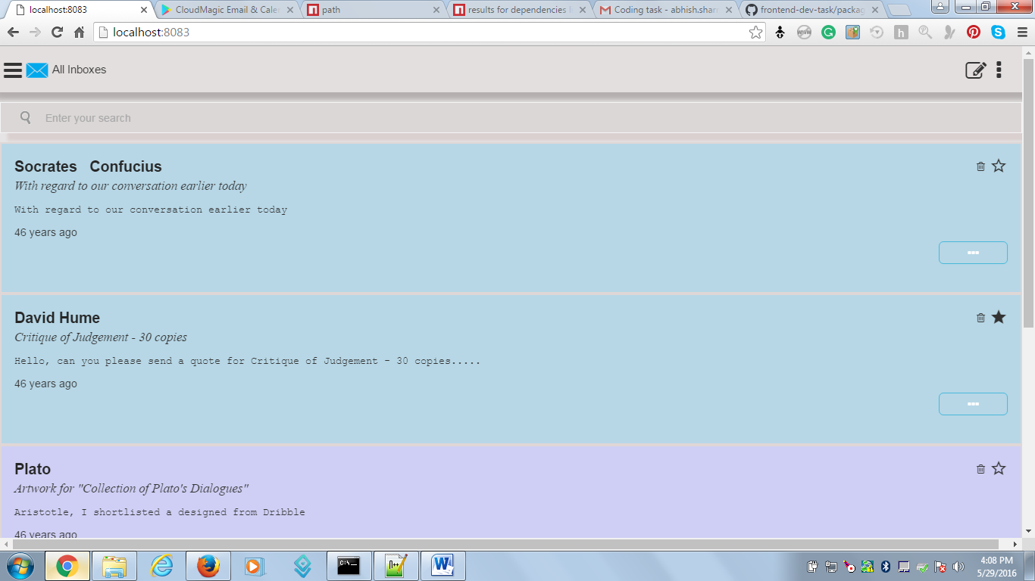

## Differentiating between the read and unread mails so the user can be more alert about his new mails:-

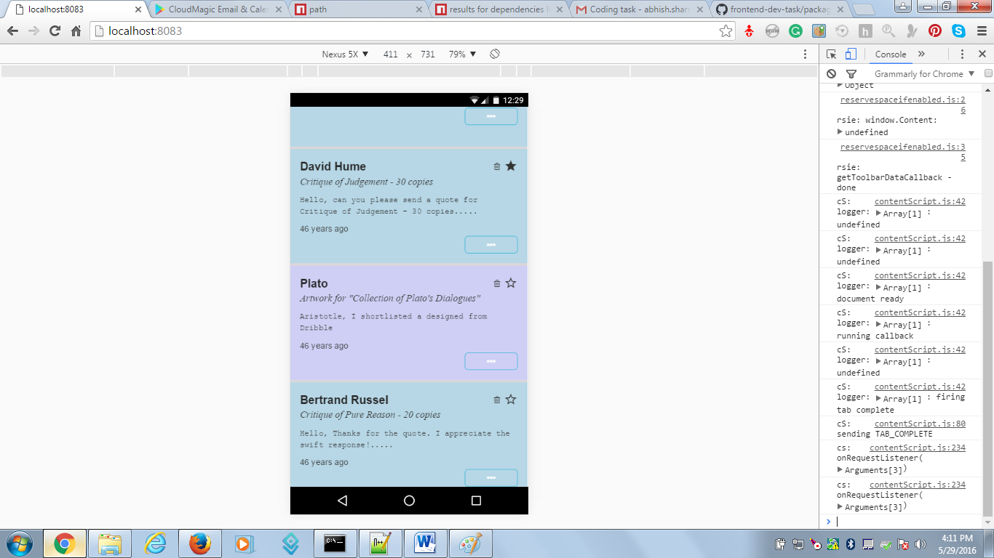

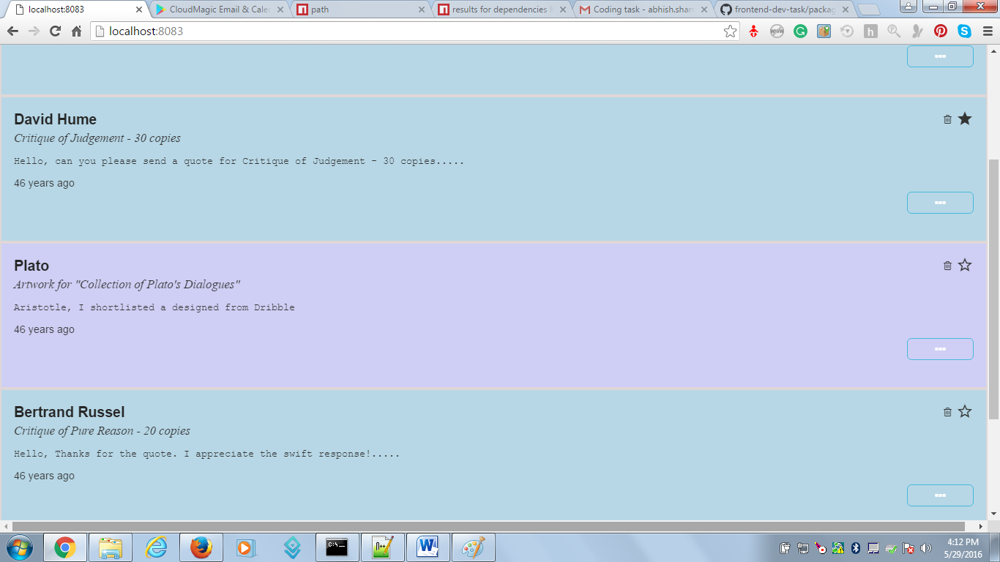

## Opening Down the message content by just clicking on the three dots button. Also you can easily scroll over the message module to see your message clearly.

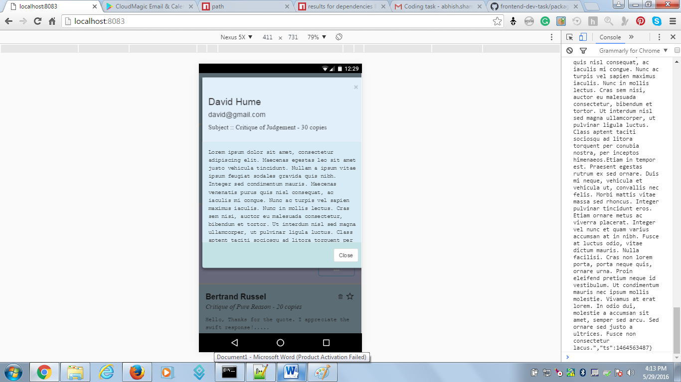

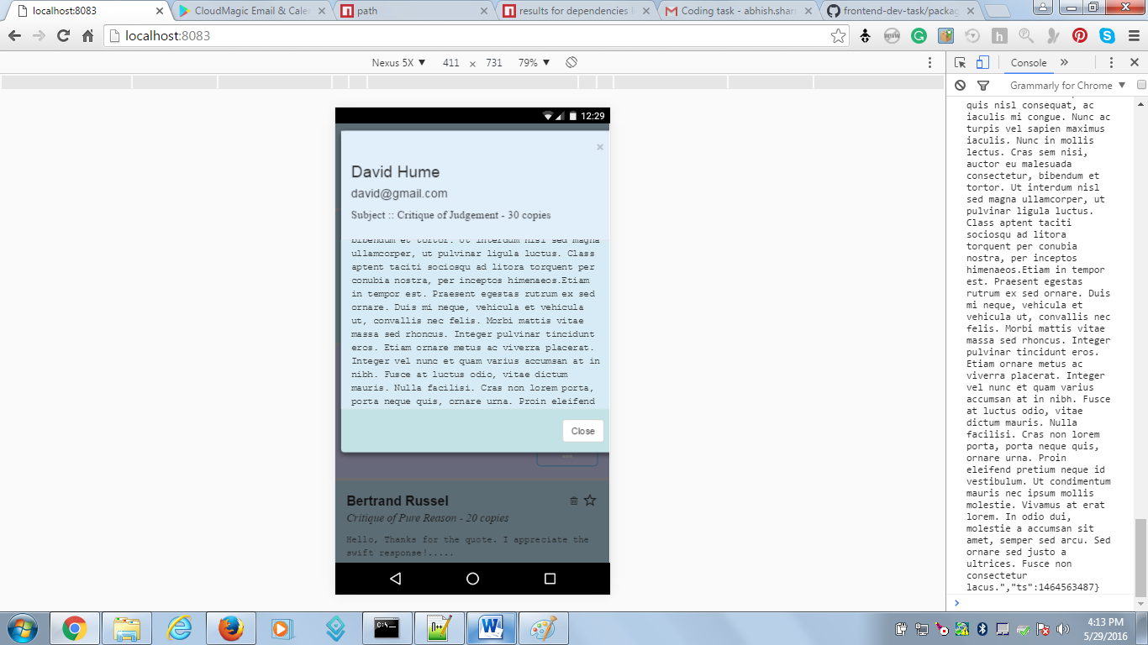

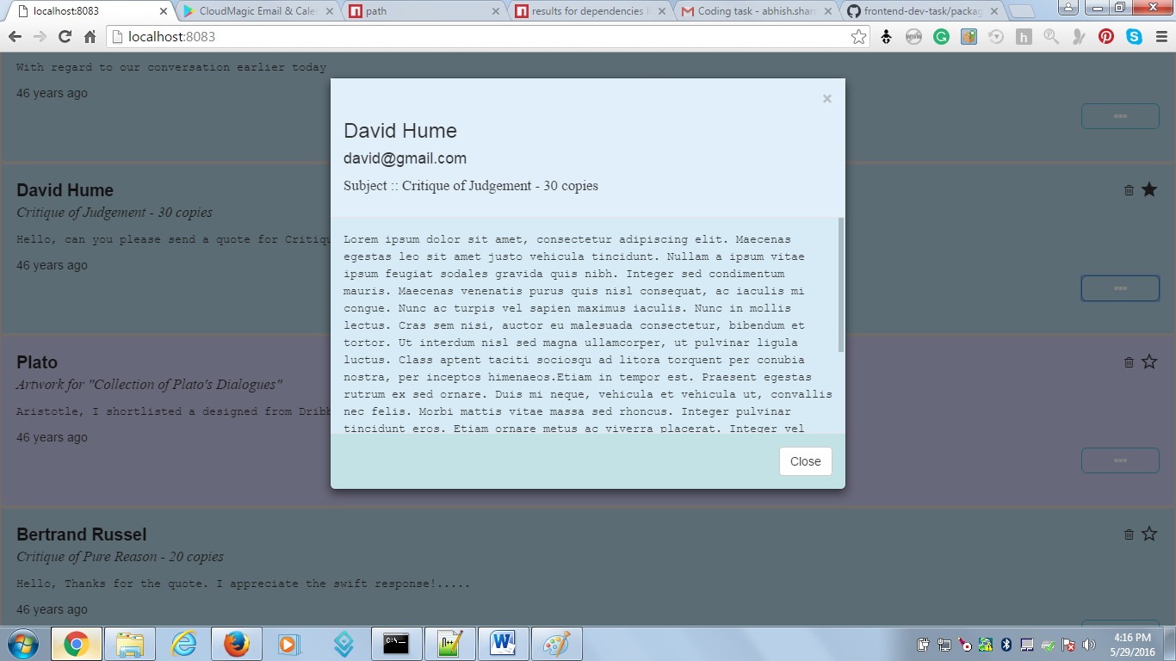

## To delete any unwanted message just go to the dustbin tab and click. It will delete the message.

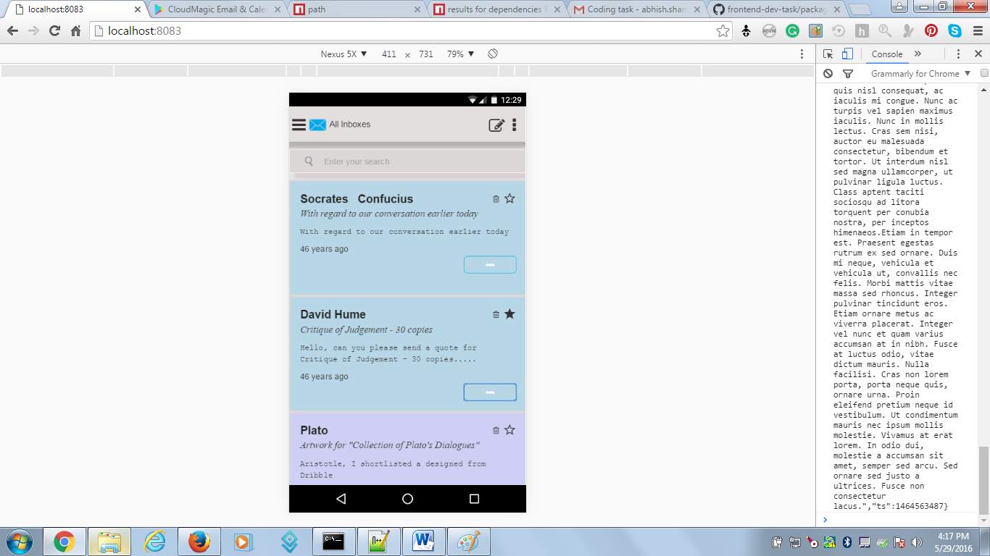 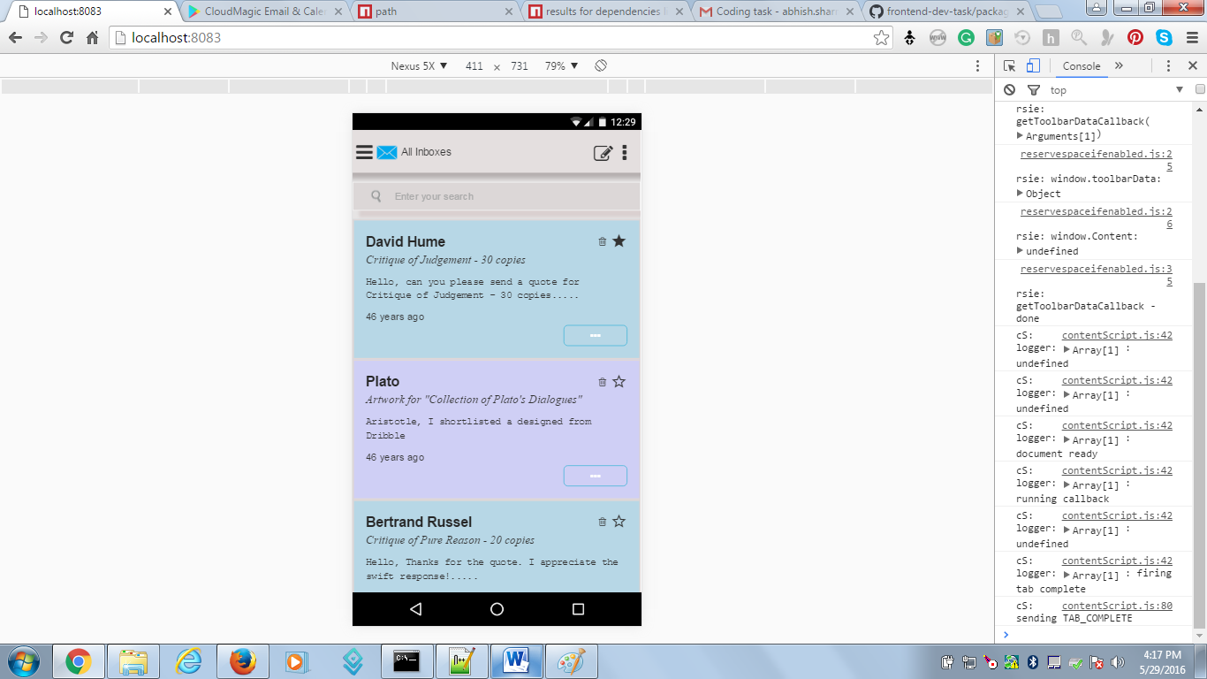

Hope you enjoyed my task.

You can contact me over my phone @994015641

@Mail : [abhish.sharma74542@gmail.com](mailto:abhish.sharma74542@gmail.com)

Or over skype : abhi74542

Regards,  
Abhishek